Please download the project from this link <https://github.com/miariany/ReactJs-hello-project>

Here is React JS import and demo application document instruction.

1. Copy folder “hello-project” into C:\Program Files\nodejs folder. Which nodejs folder have been initiate as node js module.
2. Import hello-project into **Visual Studio Code** editor by accessing File>Open Workspace> Choose hello-project.

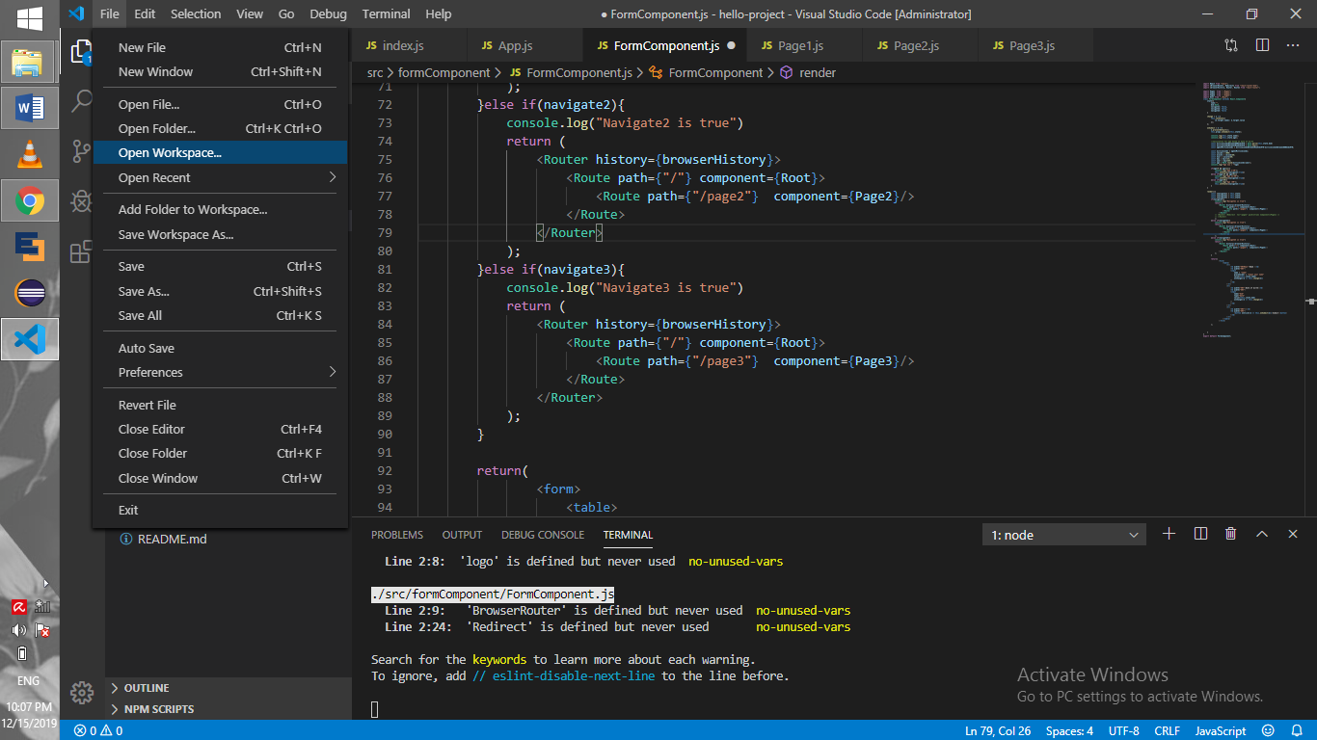

1. Start the application by opening Terminal> New Terminal

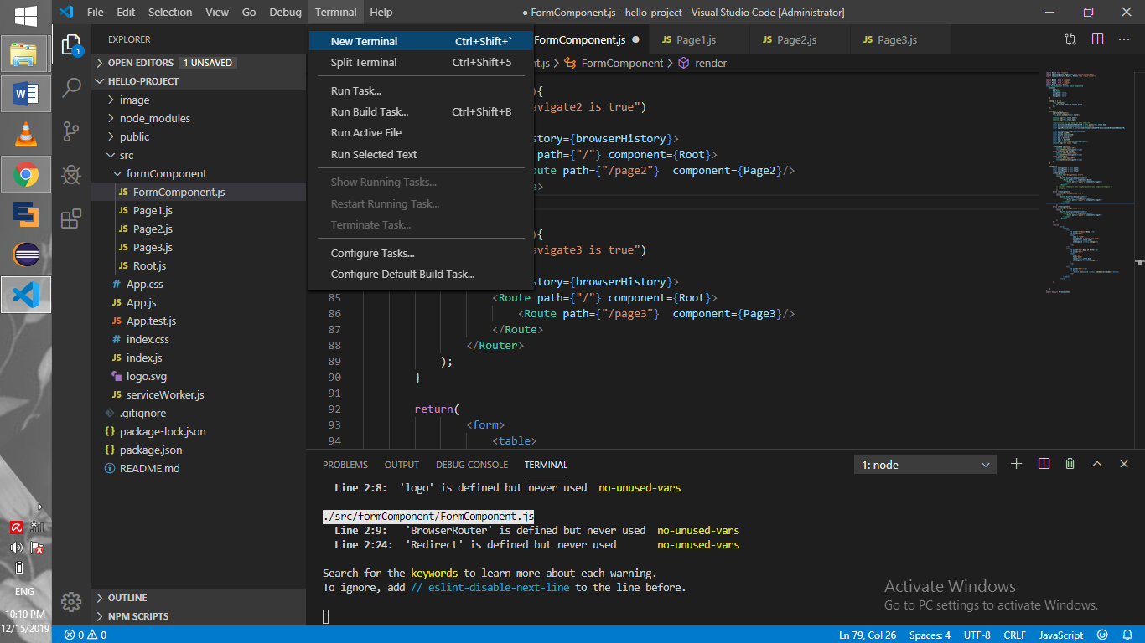

1. When terminal opened in the down part of VS Code, type “npm-start” in the console. Then it will starting the server, wait a few minutes until Chrome or Default Browser will pop up and home page of the application will show up.

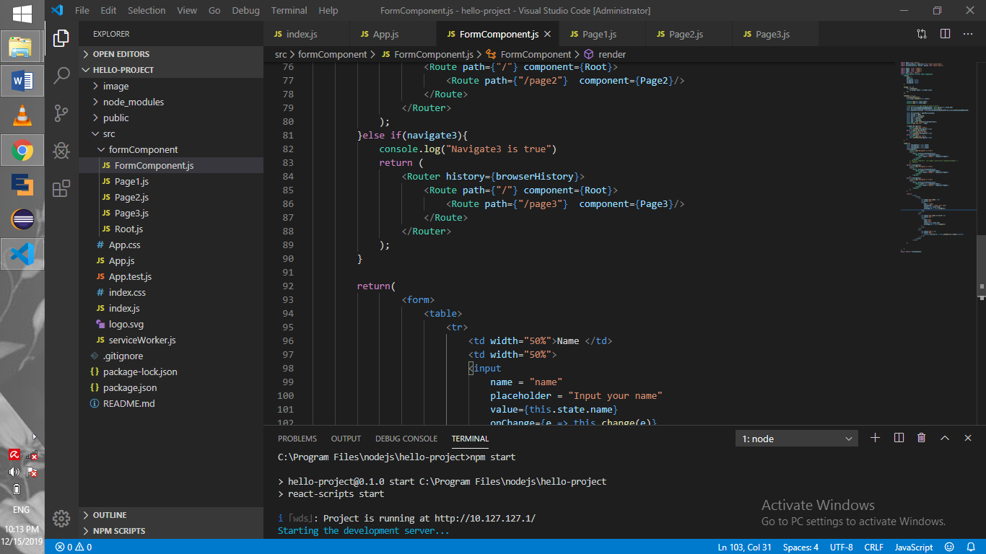

1. Application default page.

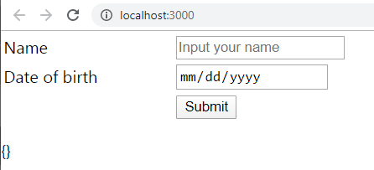

1. To test the page, please fill up the form. Below is the demo of the application. User fill up name and date of birth.

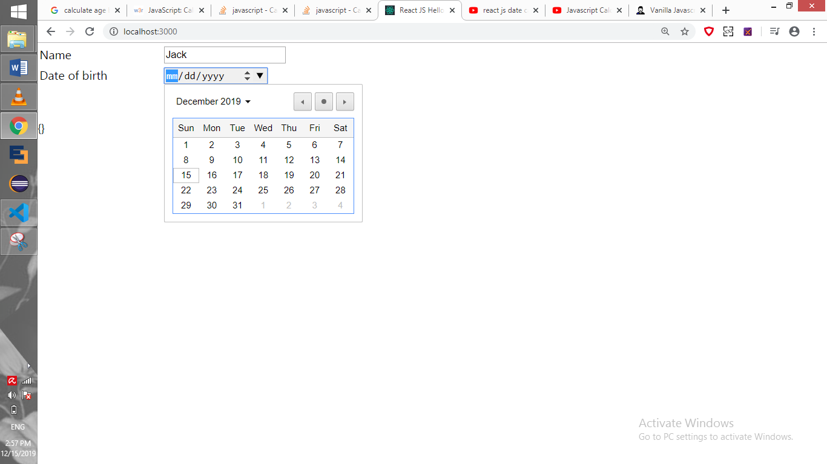

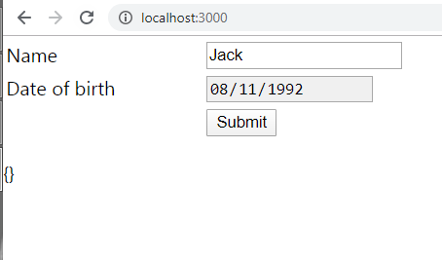

1. Click Submit Button. Then it will show JSON object data in the new page. However, it supposed to be able to load/route to a new page as the logic requested. But, the router function didn’t work so well. So it only load an empty page with JSON Object without loading Page2.js component.

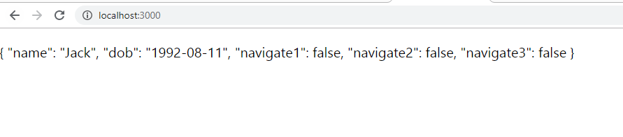

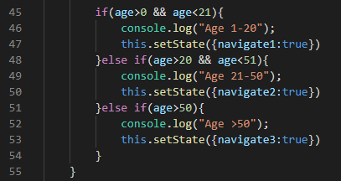

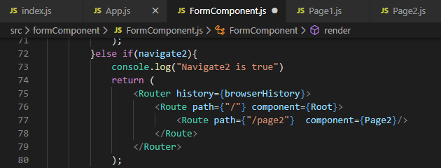

When tracing the log by inspecting Chrome page (F12), it successful meet the condition of navigate2 where age is between 21-50. Console log showed “Navigate2 is true”, means it will route to page2. But page2 component did not display as expected. However there is no error showed in the terminal or in the Chrome console as well. Where it takes me a lot of time to figure out what is wrong with the program.

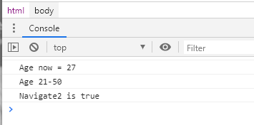

On this application routing to new page or redirect new page did not work. I was trying few ways to change the logic based on article in the internet. But I still have issue with redirecting page.